**MNIST Project**

Design a project from the MNIST dataset to identify digit classification using the SVM

algorithm.

Libraries and Software’s used:

Libraries-

1. numpy
2. pandas
3. seaborn
4. matplotlib
5. sklearn
   * svc
   * scale
   * metrics
   * confusion_matrix
   * 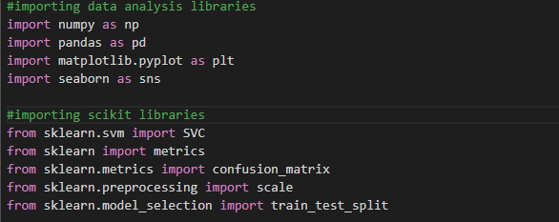train_test_split

### Software’s -

1. Google Colaboratory
2. MS Word

Importing dataset and reading data:

Using pd.read_csv() method we import our dataset.

Here we can see the data contains labels and pixel values which are nearly 42000.

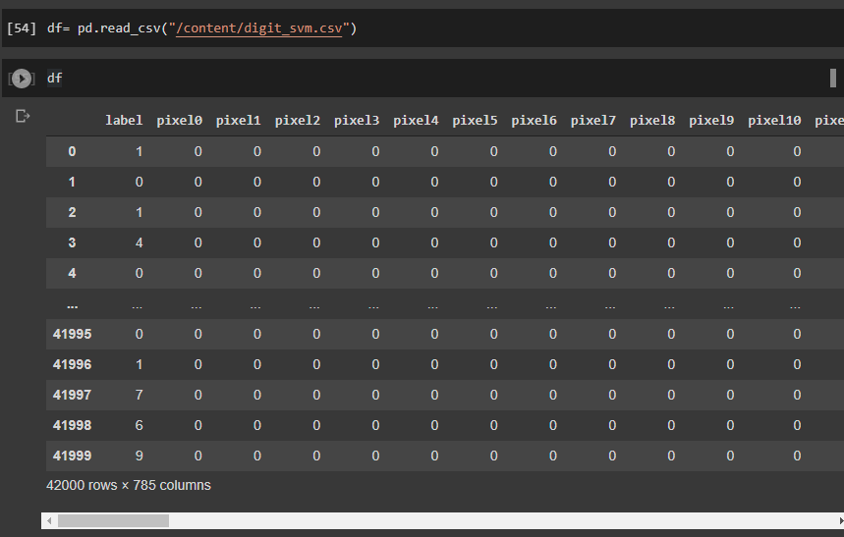

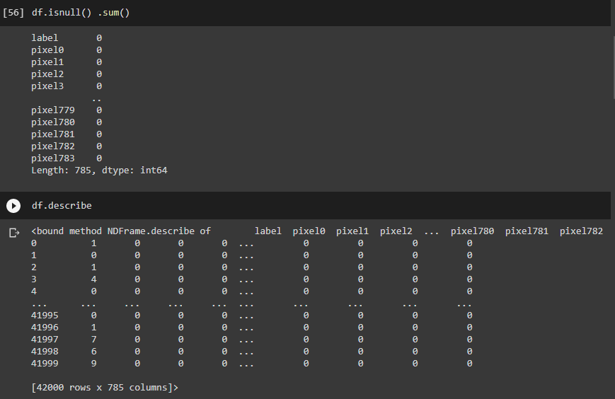Checking for Null values and the dataset contents:

As we can see this dataset has no null values.



This shows the basic statistical information about the dataset.

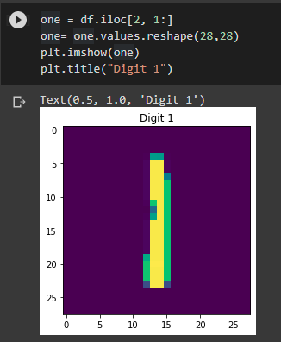Visualising dataset:

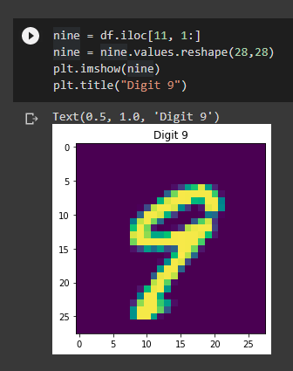 **Digit 9 Digit 1**

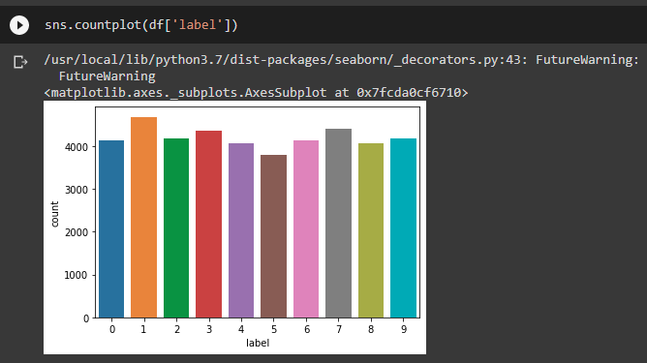

Plotting the graph between Labels and count.

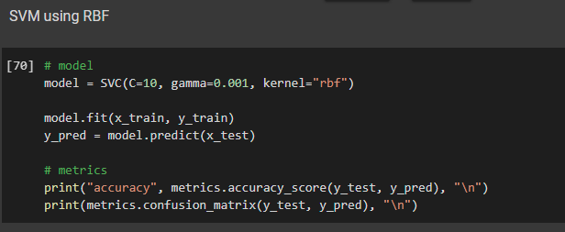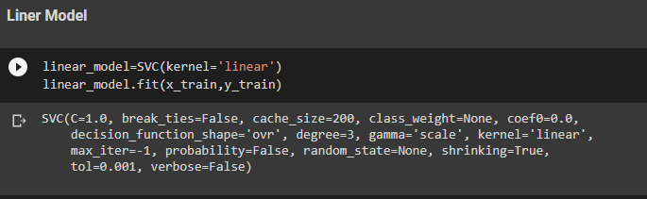Implementing dataset and applying machine learning algorithms:

Visualizing the testing dataset:

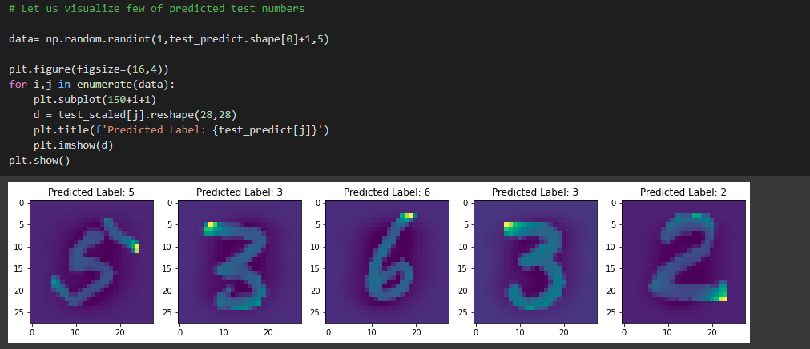

Exporting the predicted values:

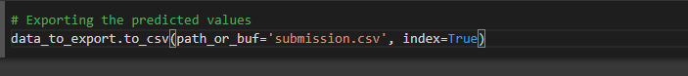

Using data_to_export () method to export our predicted values to a .CSV file.

Conclusion:

In this, SVM (Support Vector Machine) machine learning algorithms are applied on the dataset and the classification has been done using algorithms of SVC gives good accuracy of 92% in linear, 95% in poly and 98% by rbf. It is clear that the Model improves accuracy and precision of recognizing the handwritten number of MNIST data